Assignment 2: Create the following Fields in the custom object/tab (Indeed)

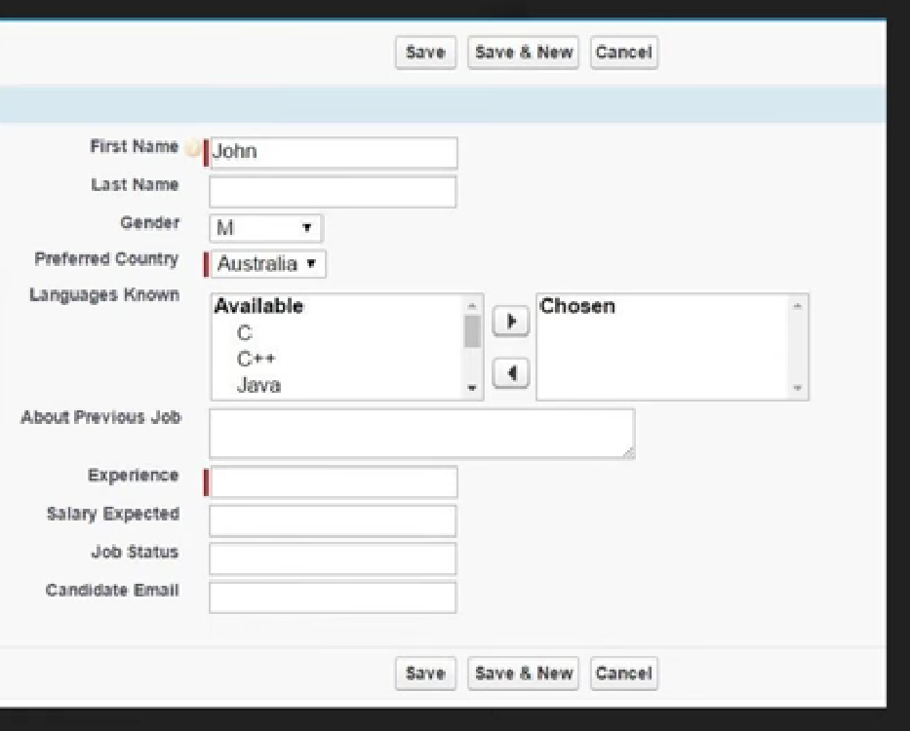

Step 1: Select the Settings icon in the top right corner
Step 2: Select Setup
Step 3: Click on the Object Manager option

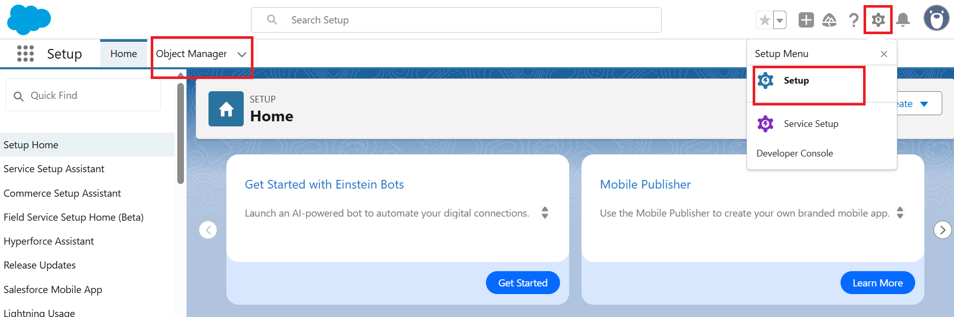

Step 4: Search the Custom Object/Tab (Indeed)
Step 5: Click on the Custom Object/Tab (Indeed)
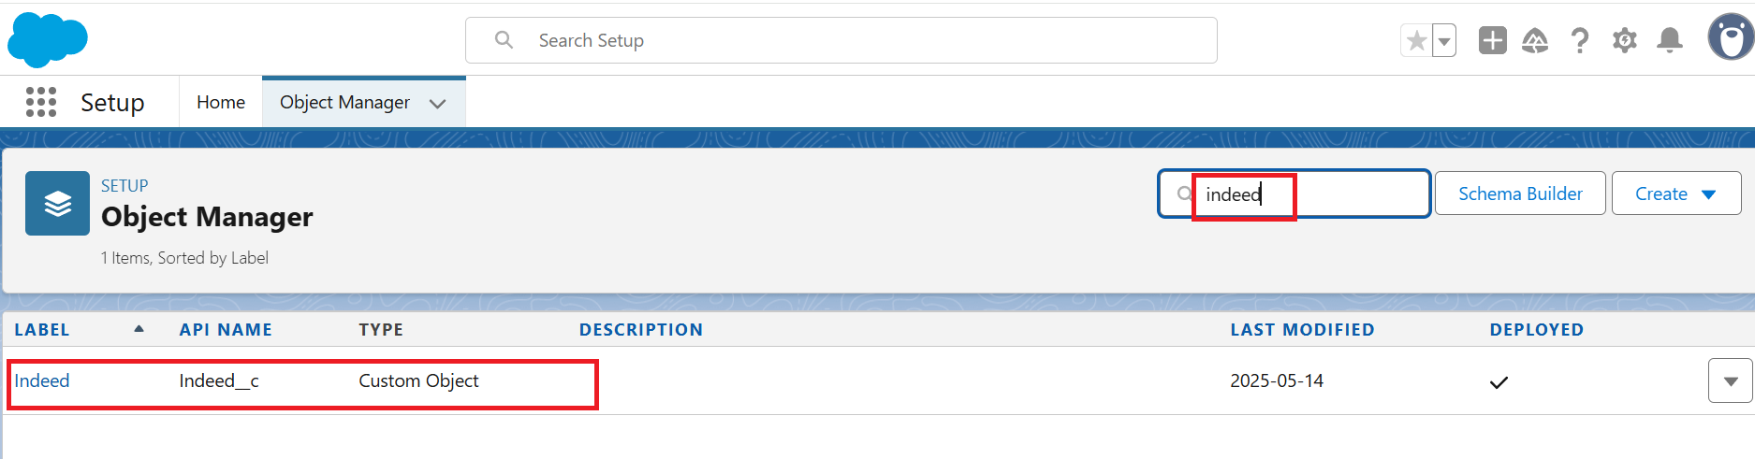

Step 6: Select the Fields & Relationships option
Step 7: Click on the New button

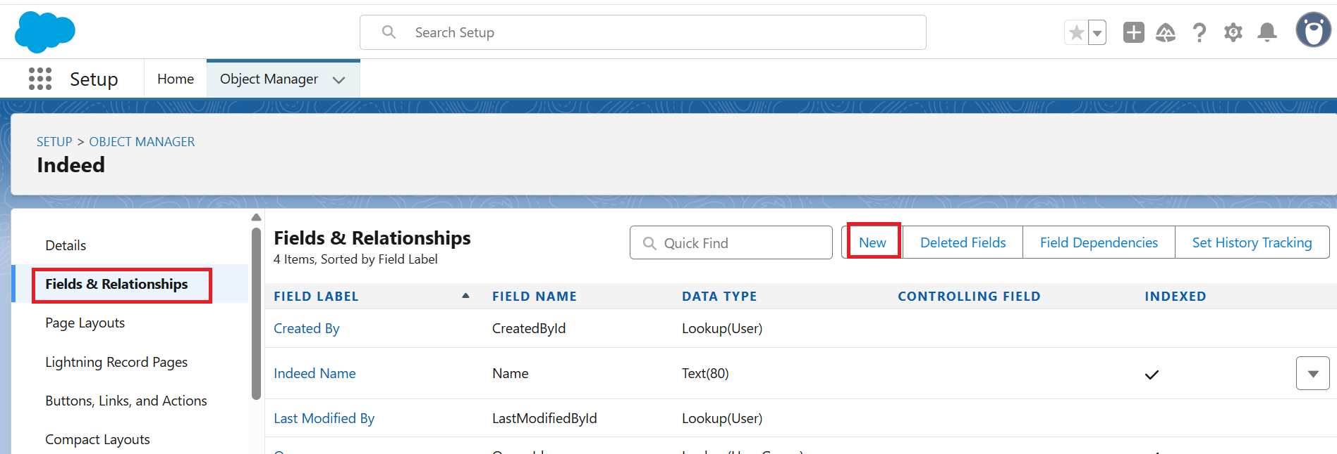

Step 8: For First Name, select Text Data type
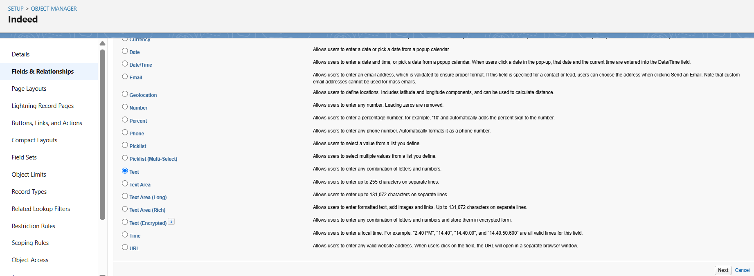

Step 9: Enter the Field Label and other required fields as per the requirement
Step 10: Click on the Next button
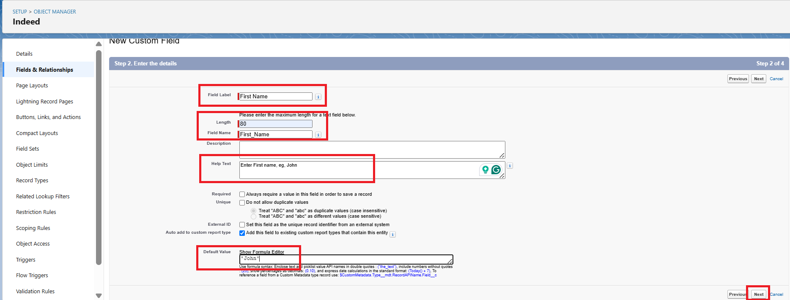

Step 11: Select the check boxes for Read Access and Edit Access as per requirements
Step 12: Click on the Next button

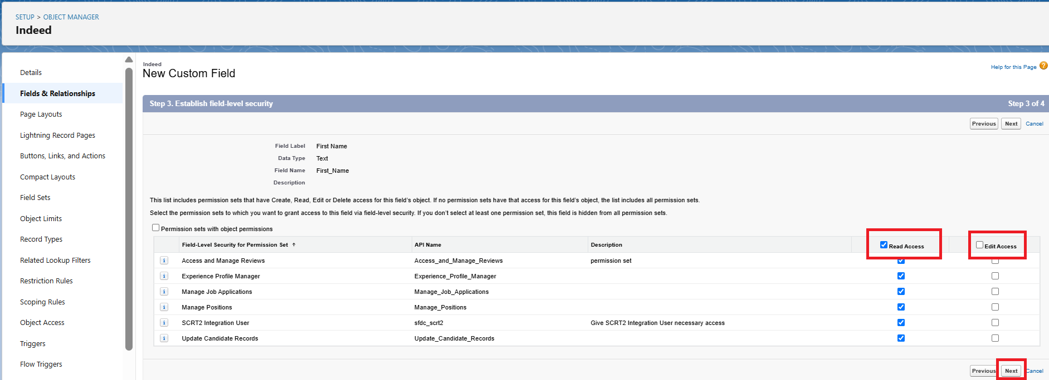

Step 13: Select the Page layout for the field
Step 14: Click on the Save

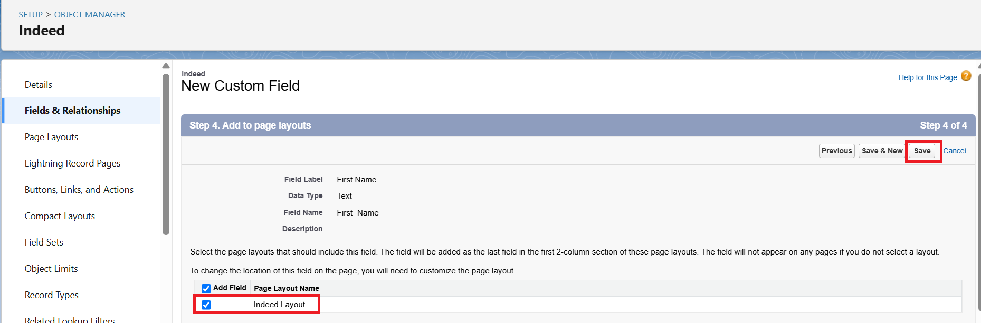

Step 15: Select the Fields & Relationships option
Step 16: Click on the New button

Step 17: For Last Name, select Text Data type

Step 18: Enter the Field Label and other required fields as per the requirement
Step 19: Click on the Next button
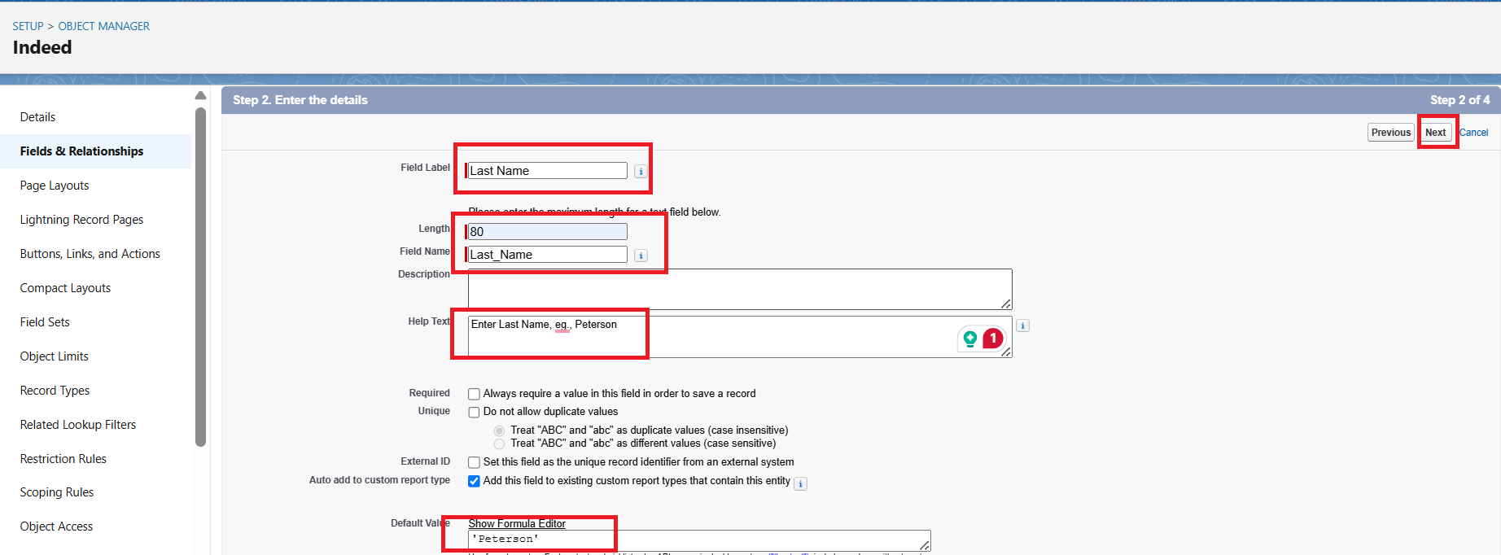

Step 20: Select the check boxes for Read Access and Edit Access as per requirements
Step 21: Click on the Next button

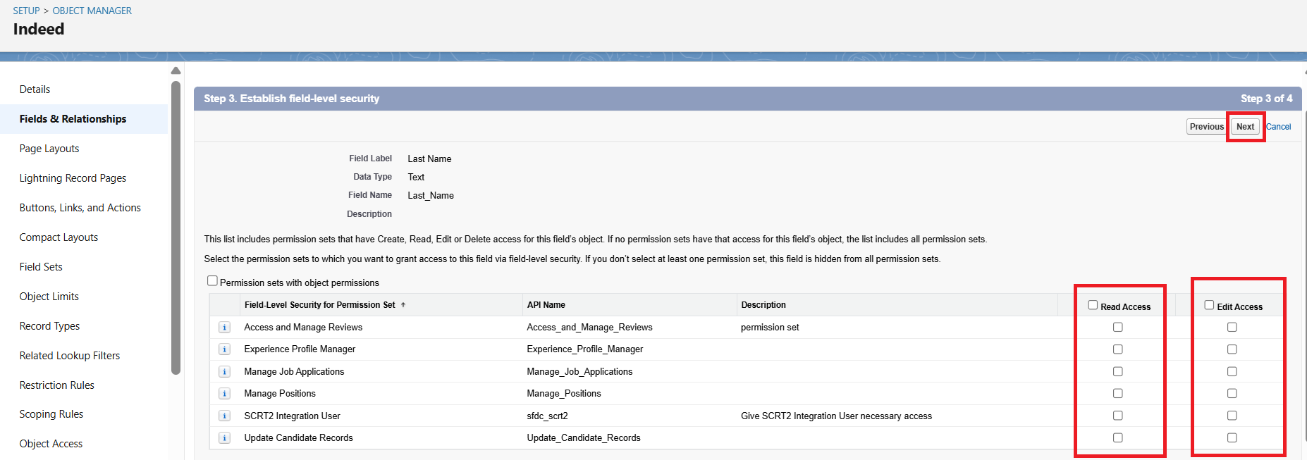

Step 22: Select the Page layout for the field
Step 23: Click on the Save

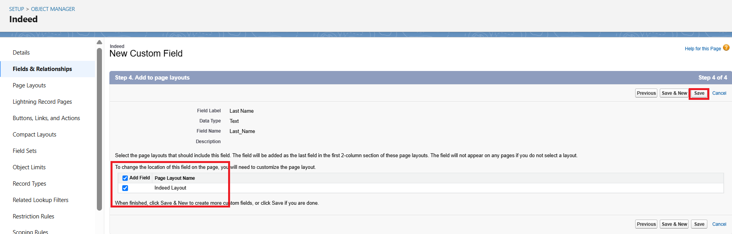

Step 24: Select the Fields & Relationships option
Step 25: Click on the New button

Step 26: For Gender, select Picklist Data type
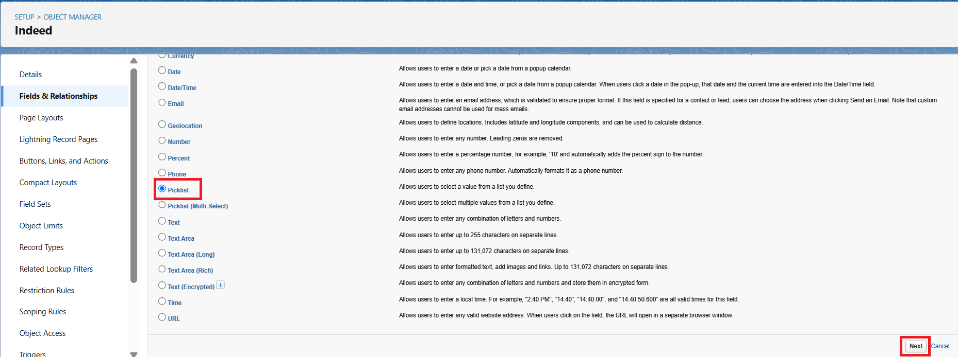

Step 27: Enter the Field Label “Gender“
Step 28: Select Enter values, with each value separated by a new line
Step 29: Enter Values in the box: Male, Female, Prefer Not to Say, and also select other required fields as per the requirement
Step 30: Click on the Next button

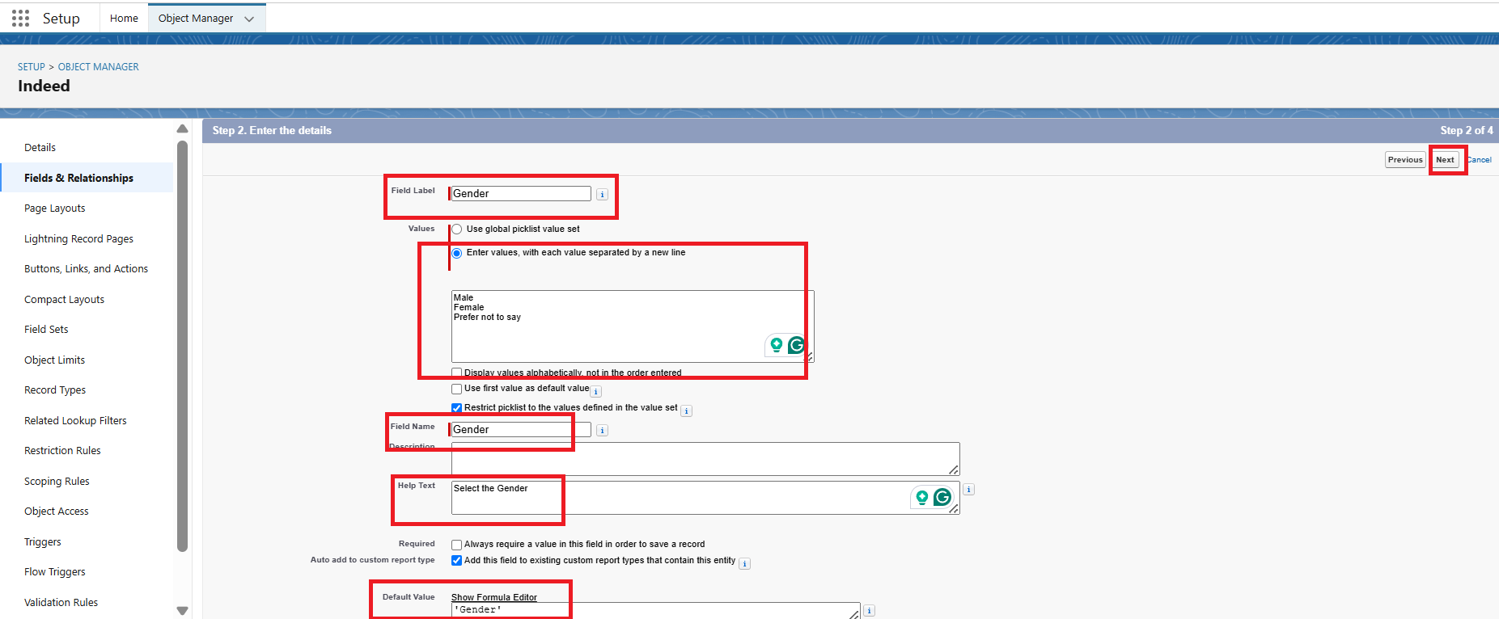

Step 31: Select the check boxes for Read Access and Edit Access as per requirements
Step 32: Click on the Next button
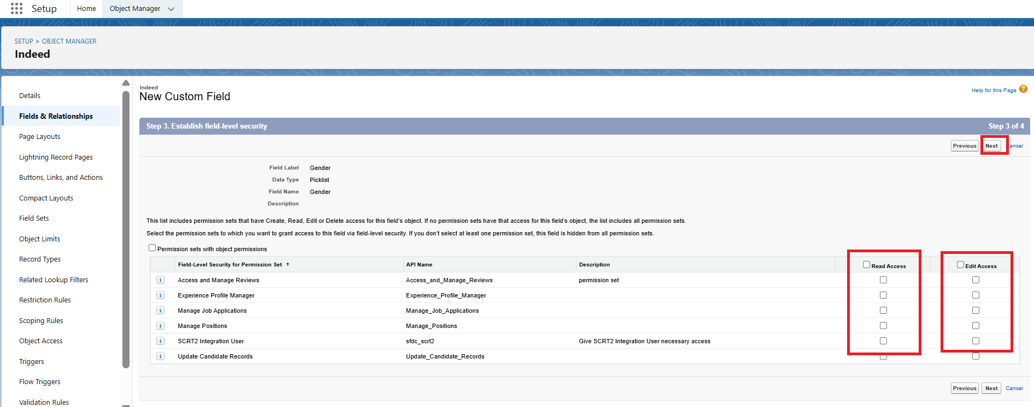

Step 33: Select the Page layout for the field
Step 34: Click on the Save

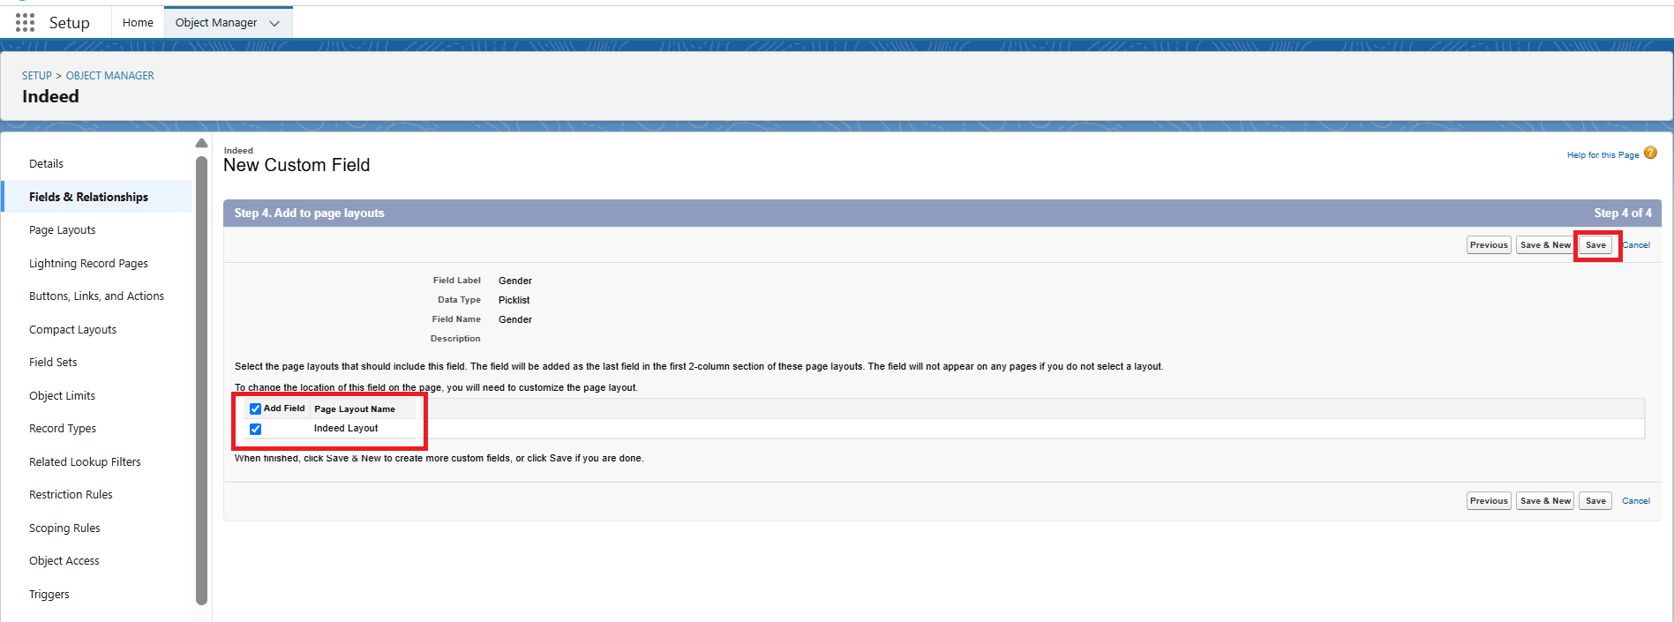

Step 35: Select the Fields & Relationships option
Step 36: Click on the New button

Step 37: For Gender, select Picklist Data type

Step 38: Enter the Field Label “Preferred Country“
Step 39: Select Enter values, with each value separated by a new line
Step 40: Enter Values in the box: United States of America, Canada, Australia, India, etc, and also select other required fields as per the requirement
Step 41: Select the Checkbox “Display values in alphabetical order not in given order
Step 42: Click on the Next button
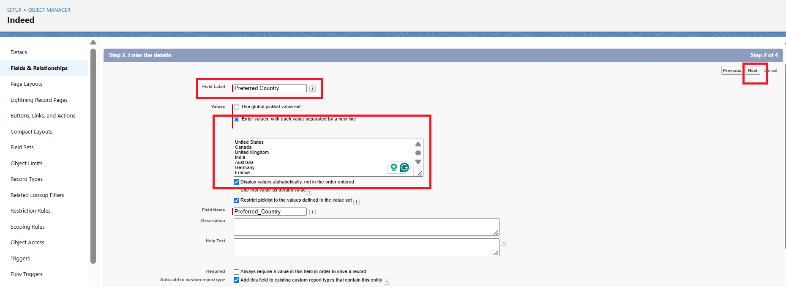

Step 43: Select the check boxes for Read Access and Edit Access as per requirements
Step 44: Click on the Next button

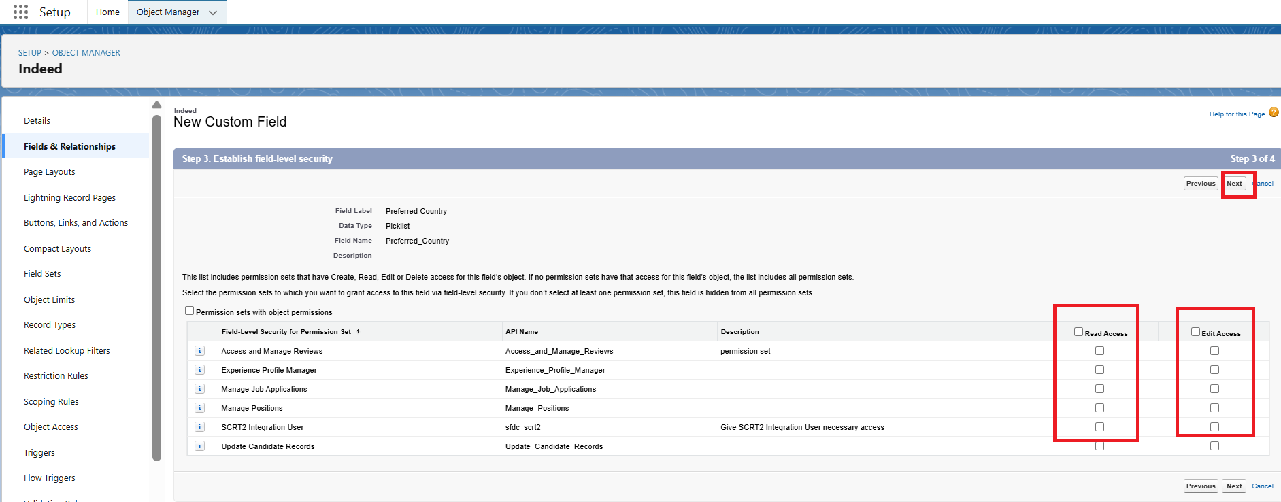

Step 45: Select the Page layout for the field
Step 46: Click on the Save

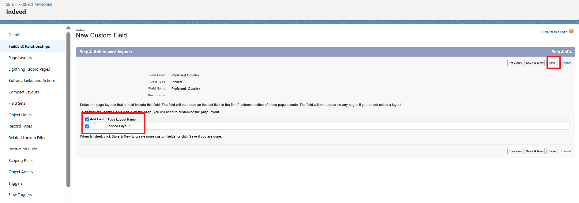

Step 47: Select the Fields & Relationships option
Step 48: Click on the New button

Step 48: For Languages Known, select Picklist (Multi-Select) Data type
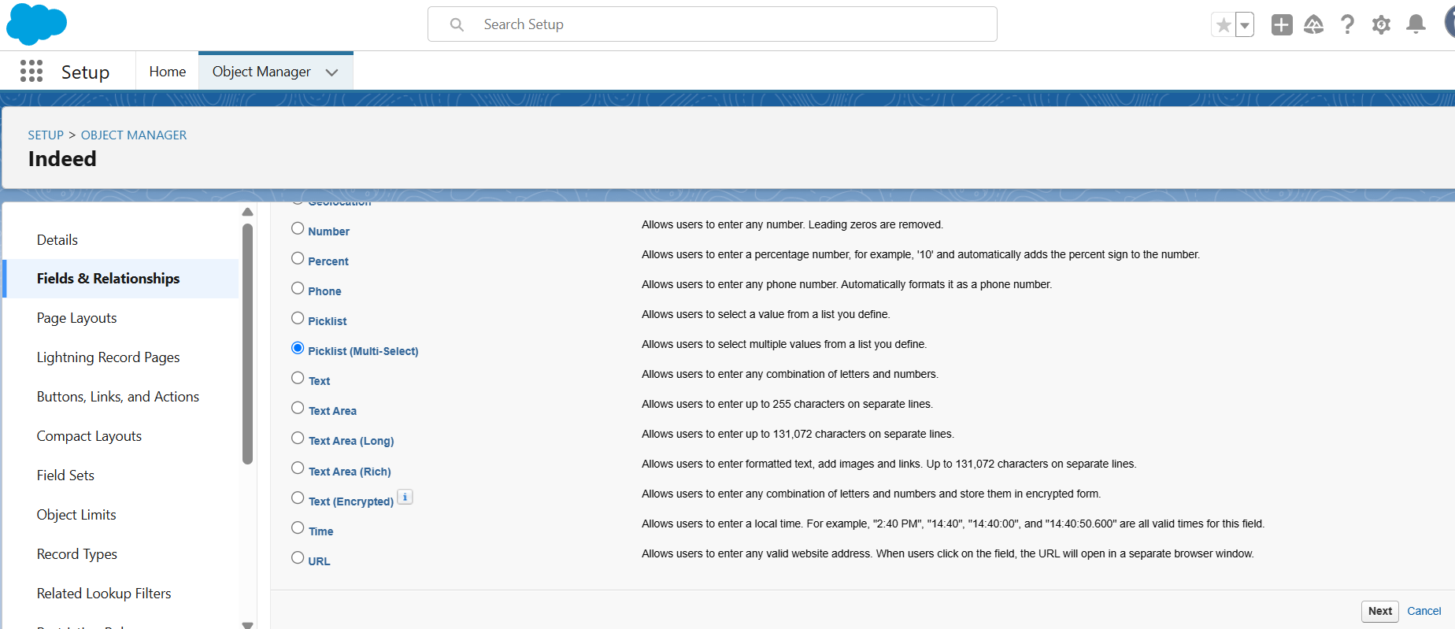

Step 49: Enter the Field Label “Languages Known“
Step 50: Select Enter values, with each value separated by a new line
Step 51: Enter Values in the box: C, C++, Java, JavaScript, .NET, HTML, CSS, and also select other required fields as per the requirement
Step 52: Click on the Next button

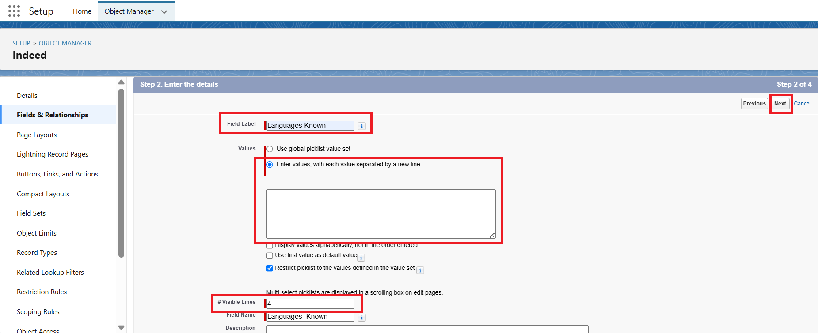

Step 53: Select the check boxes for Read Access and Edit Access as per requirements
Step 54: Click on the Next button

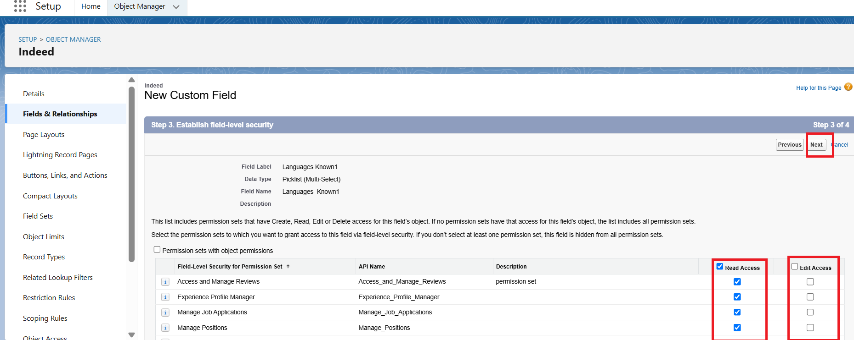

Step 55: Select the Page layout for the field
Step 56: Click on the Save

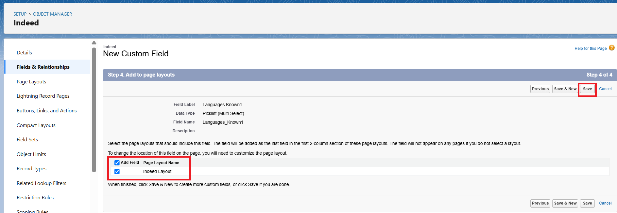

Step 57: Select the Fields & Relationships option
Step 58: Click on the New button

Step 59: For About Previous Job, select Text Area Data type
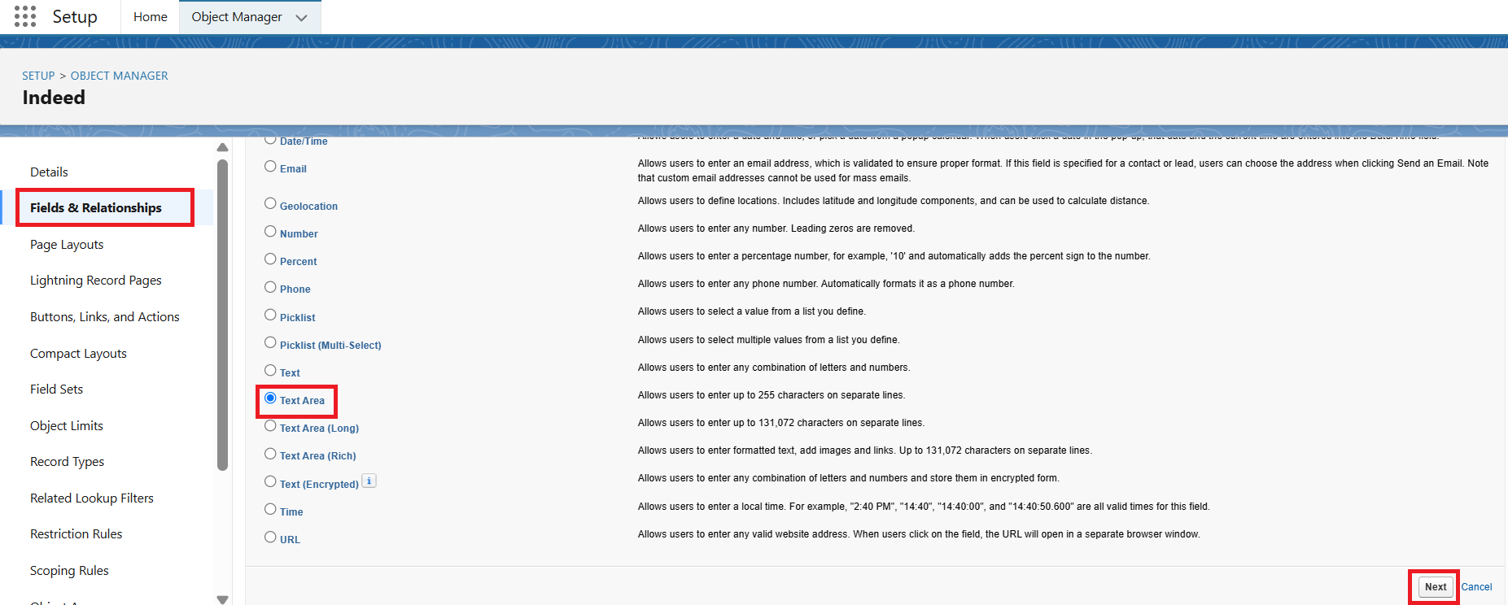

Step 60: Enter the Field Label “About Previous Job“
Step 61: Click on the Next button

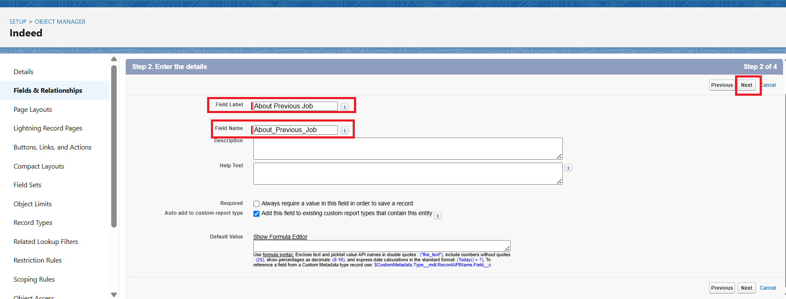

Step 64: Select the check boxes for Read Access and Edit Access as per requirements
Step 65: Click on the Next button

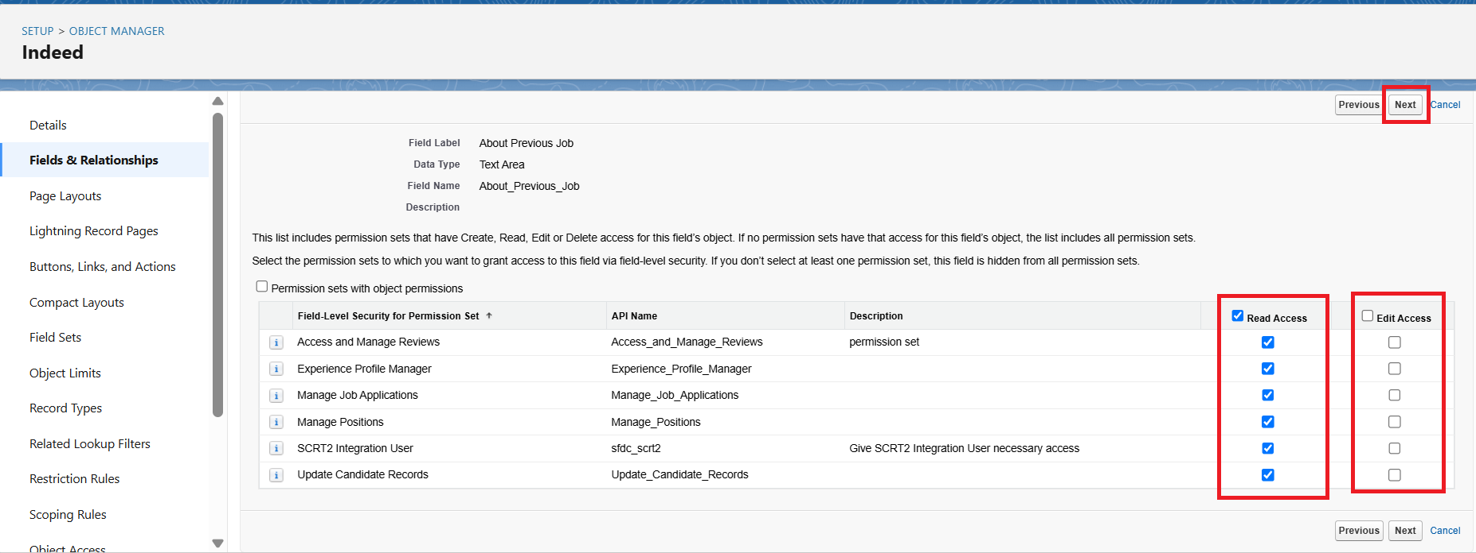

Step 66: Select the Page layout for the field
Step 67: Click on the Save

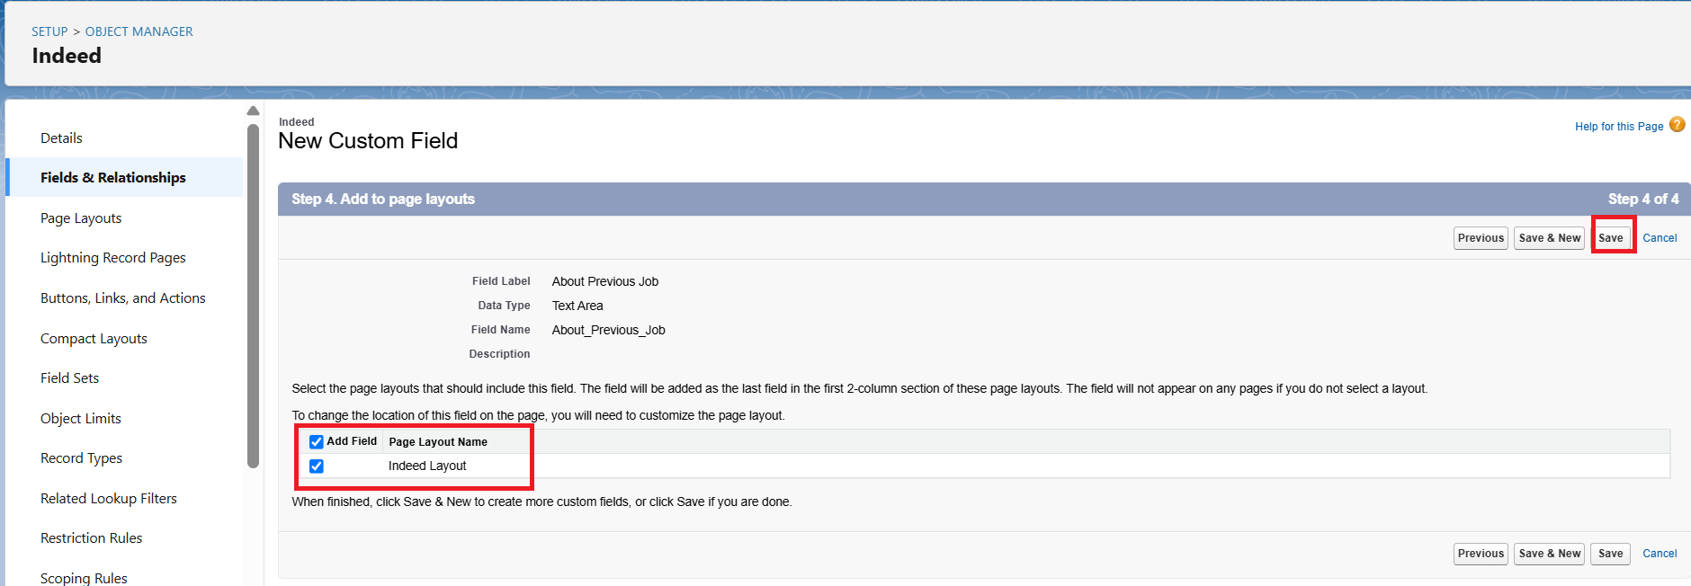

Step 68: Select the Fields & Relationships option
Step 69: Click on the New button

Step 70: For Experience, select Number Data type
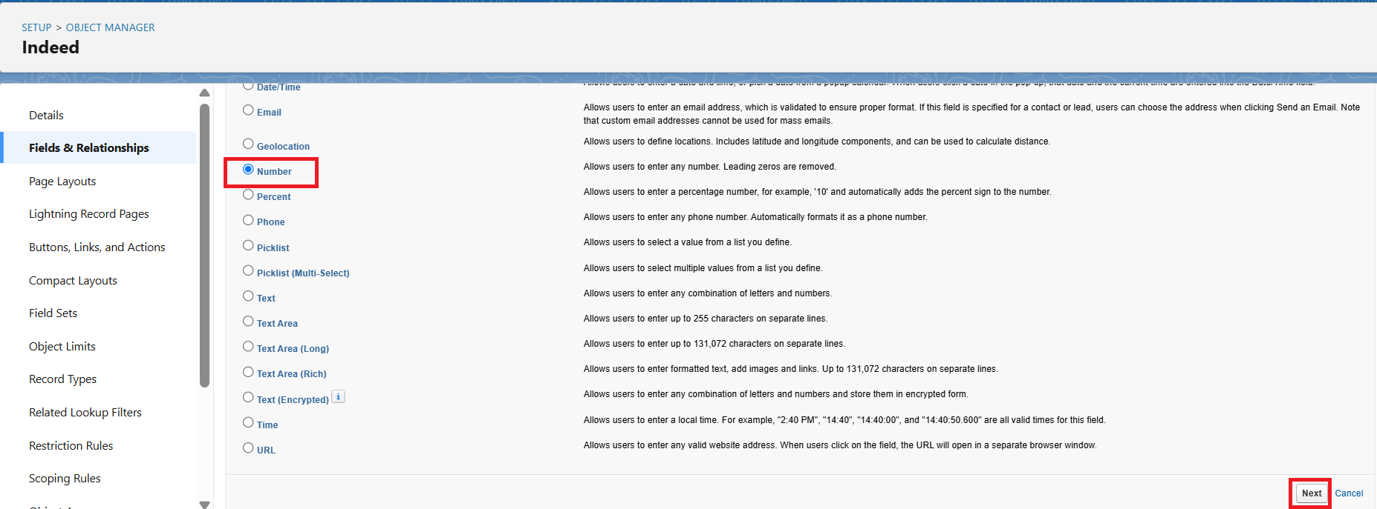

Step 71: Enter the Field Label “Experience“
Step 72: Enter a value in the Length field
Step 73: Enter a value in the Decimal places field
Step 74: Click on the Next button

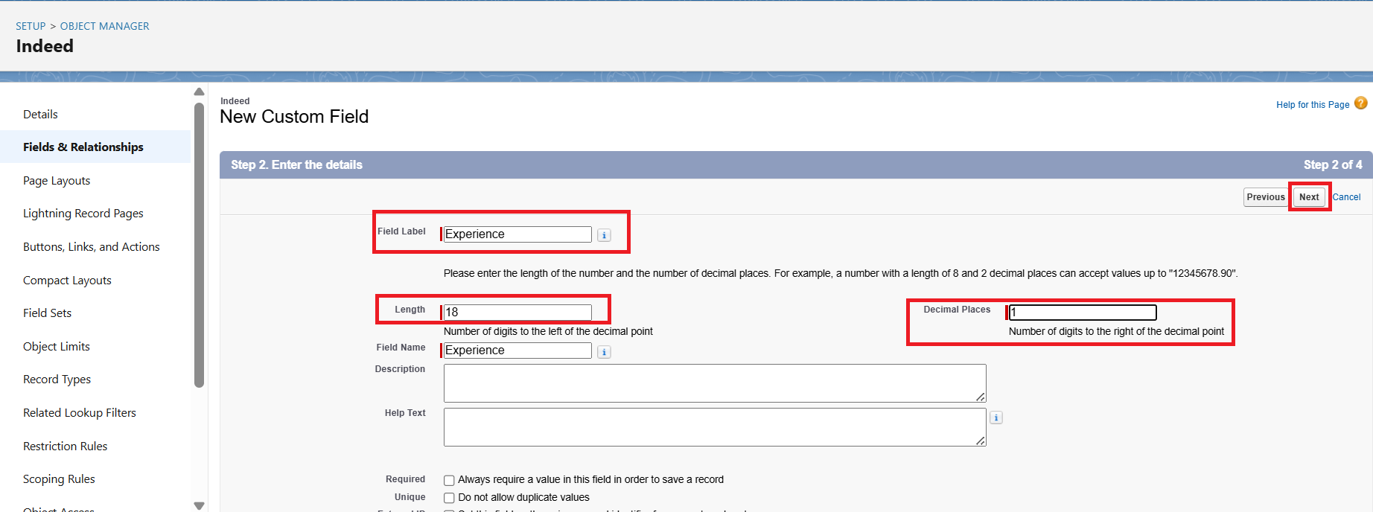

Step 75: Select the check boxes for Read Access and Edit Access as per requirements
Step 76: Click on the Next button

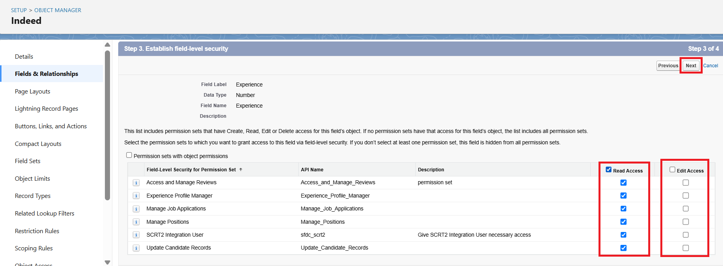

Step 77: Select the Page layout for the field
Step 78: Click on the Save

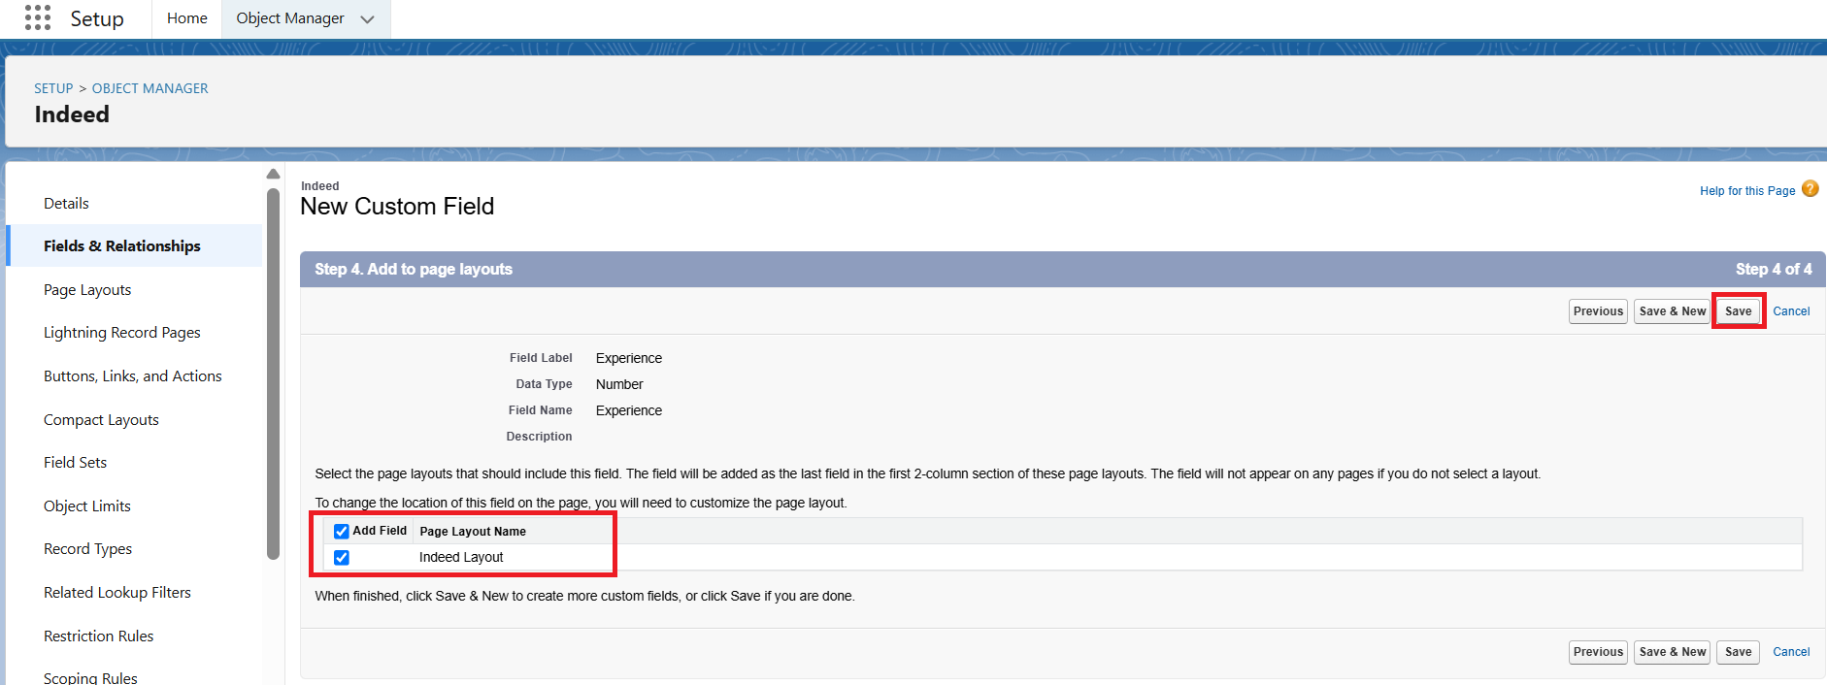

Step 79: Select the Fields & Relationships option
Step 80: Click on the New button

Step 81: For Salary Expected, select Currency Data type
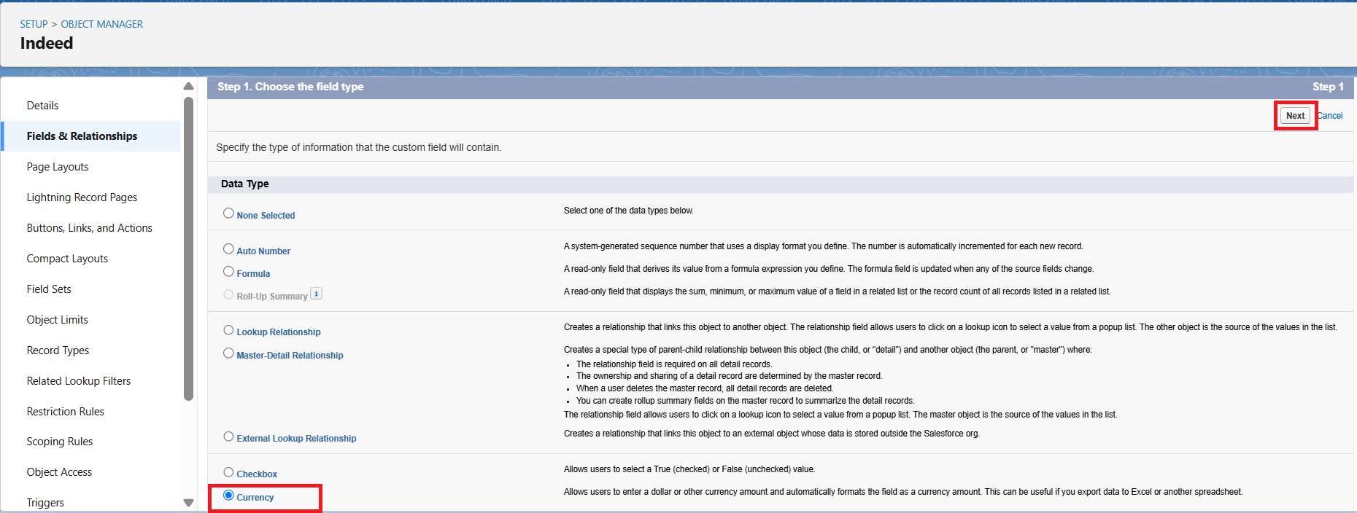

Step 82: Enter the Field Label “Salary Expected“
Step 83: Enter a value in the Length field
Step 84: Enter a value in the Decimal places field
Step 85: Click on the Next button

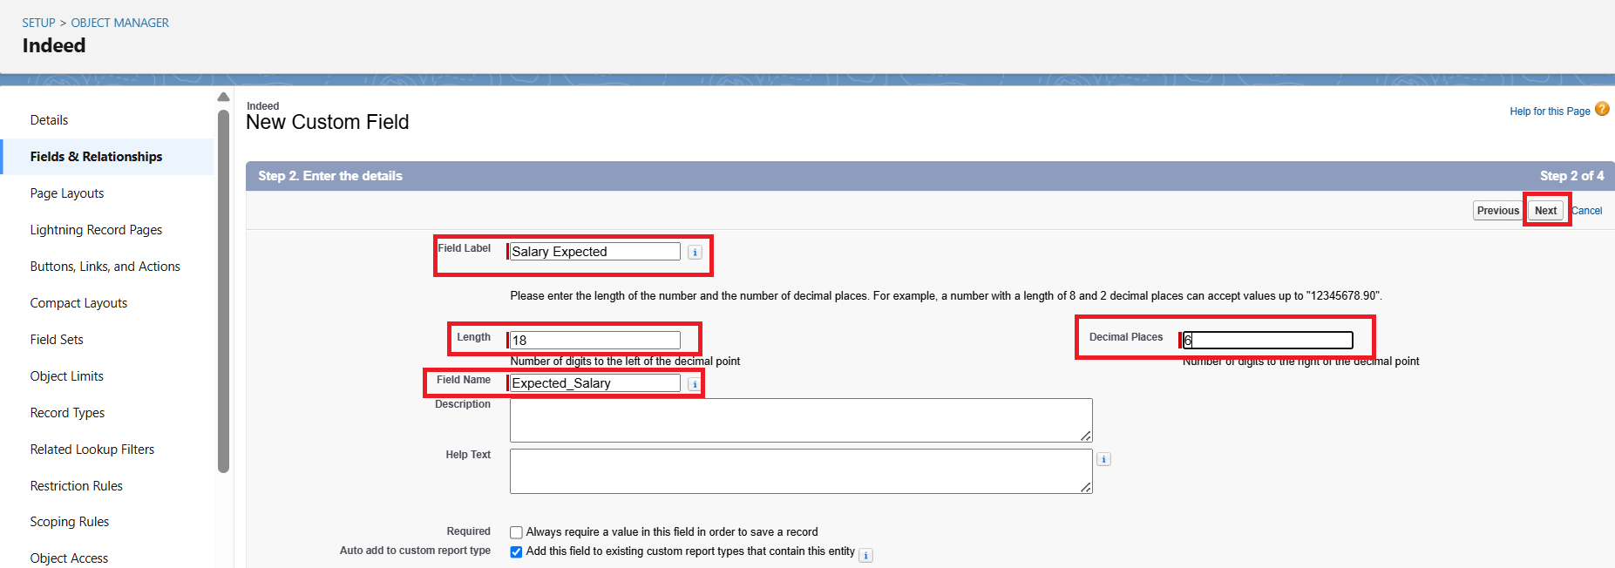
Step 86: Select the check boxes for Read Access and Edit Access as per requirements
Step 87: Click on the Next button
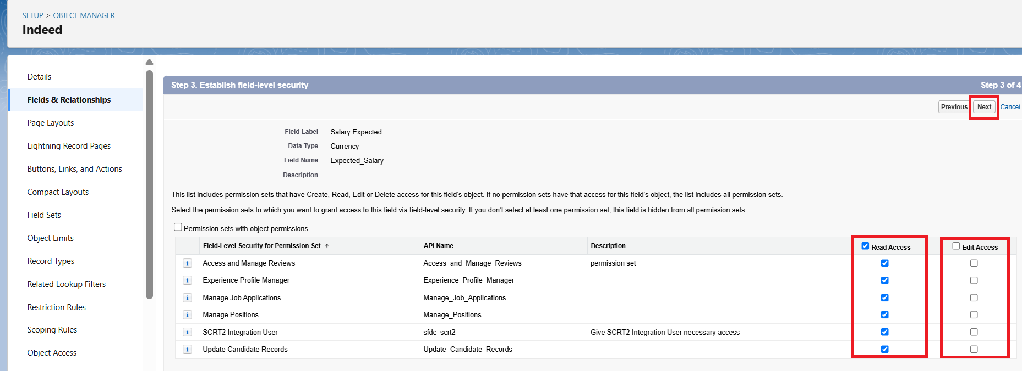

Step 88: Select the Page layout for the field
Step 89: Click on the Save

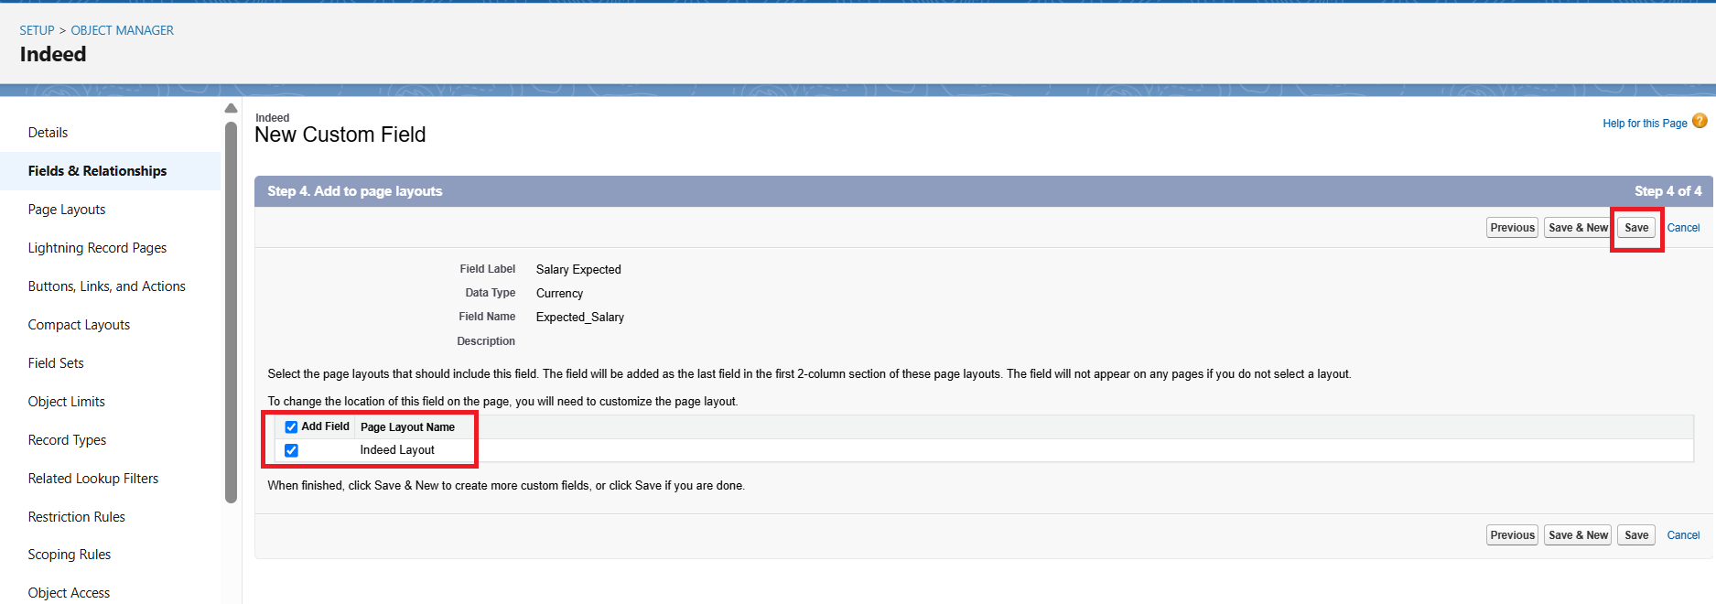

Step 90: Select the Fields & Relationships option
Step 91: Click on the New button

Step 92: For Job Status, select Picklist Data type

Step 93: Enter the Field Label “Job Status“
Step 94: Select Enter values, with each value separated by a new line
Step 95: Enter Values in the box: Employed, Unemployed, Looking for a Job, On Notice Period, Intern, Freelancing, Retired and also select other required fields as per the requirement
Step 96: Click on the Next button

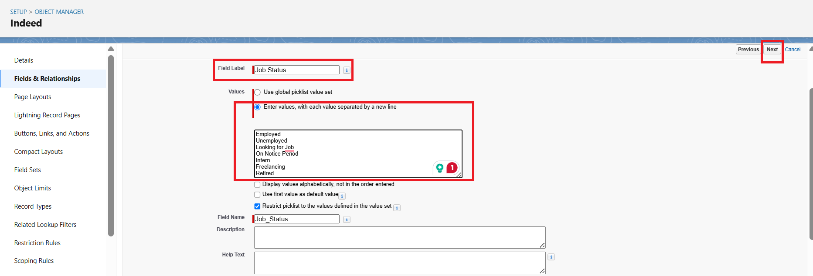

Step 97: Select the check boxes for Read Access and Edit Access as per requirements
Step 98: Click on the Next button

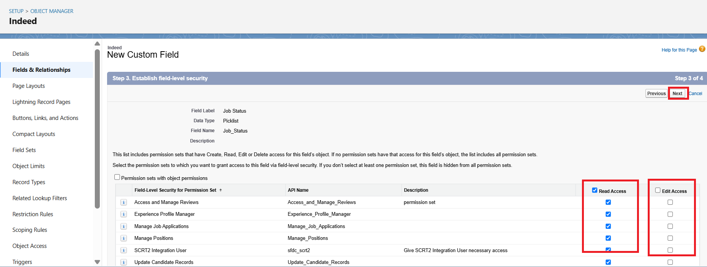

Step 99: Select the Page layout for the field
Step 100: Click on the Save

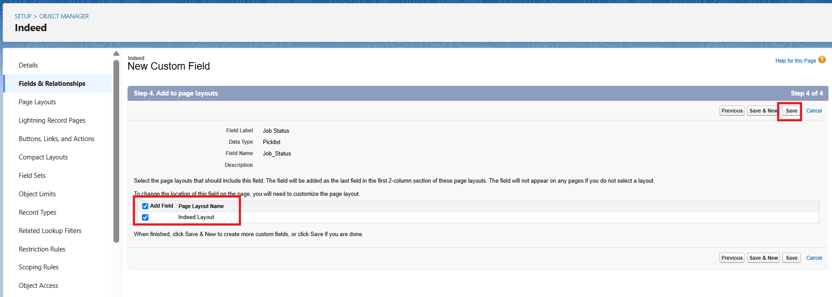
Step 101: Select the Fields & Relationships option
Step 102: Click on the New button

Step 103: For Candidate Email, select Email Data type
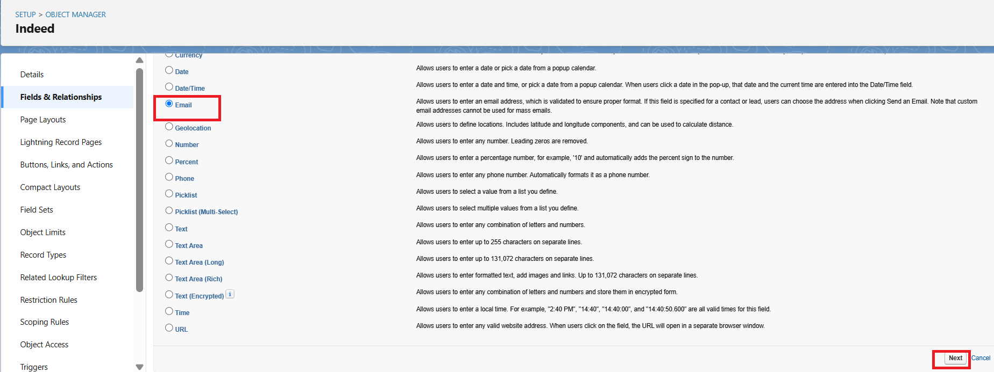

Step 104: Enter the Field Label “Candidate Email“
Step 105: Enter/select other required fields as per the requirement
Step 106: Click on the Next button
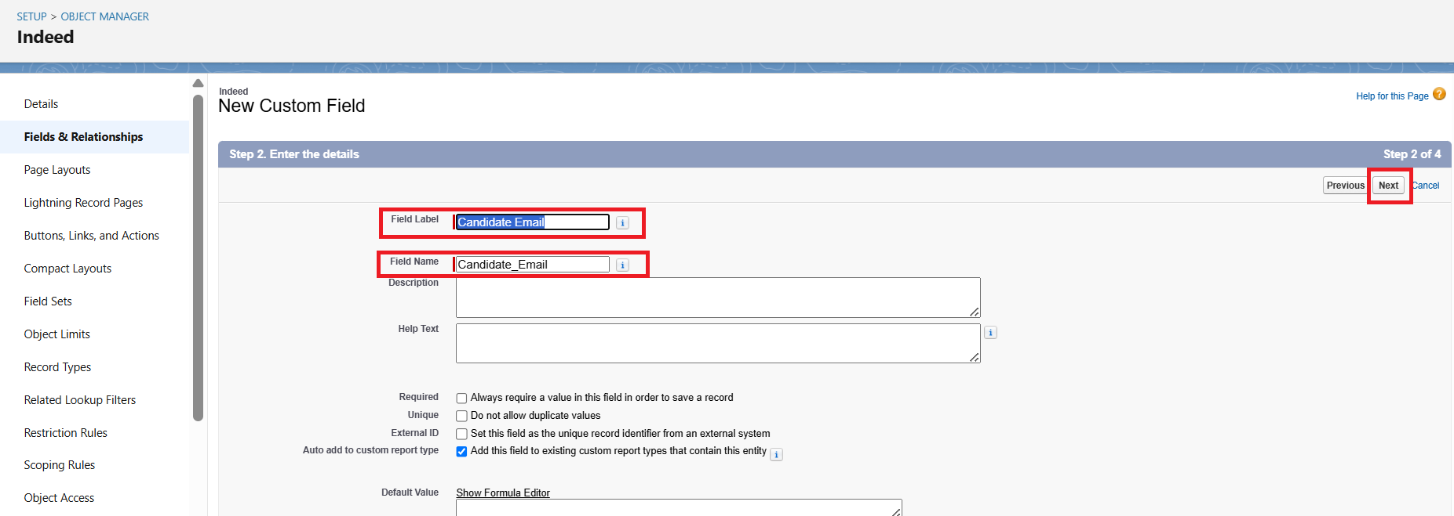

Step 107: Select the check boxes for Read Access and Edit Access as per requirements
Step 108: Click on the Next button

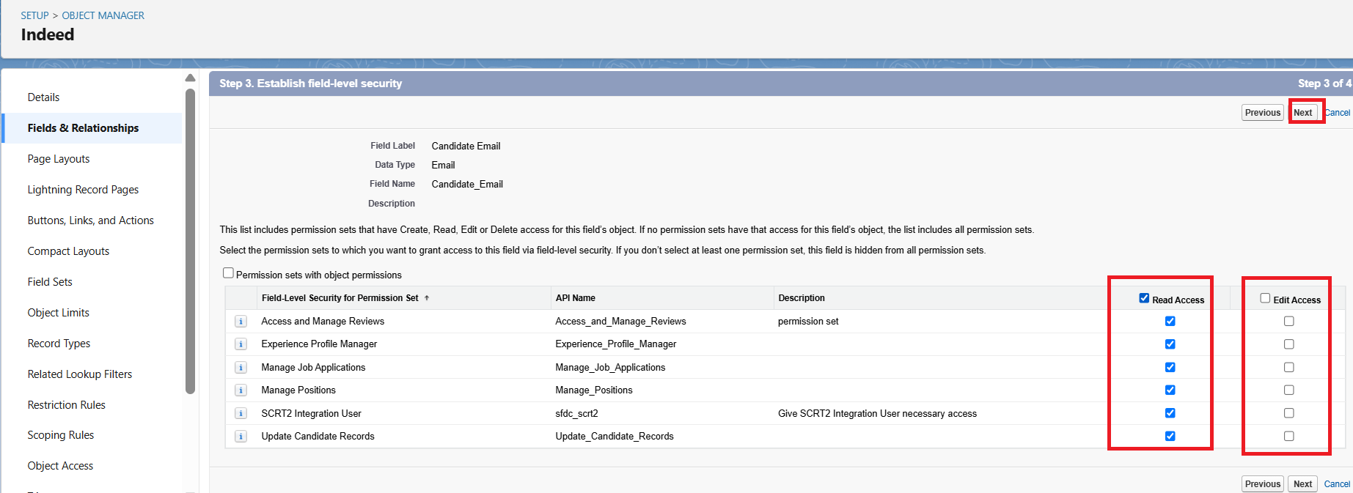

Step 109: Select the Page layout for the field
Step 110: Click on the Save

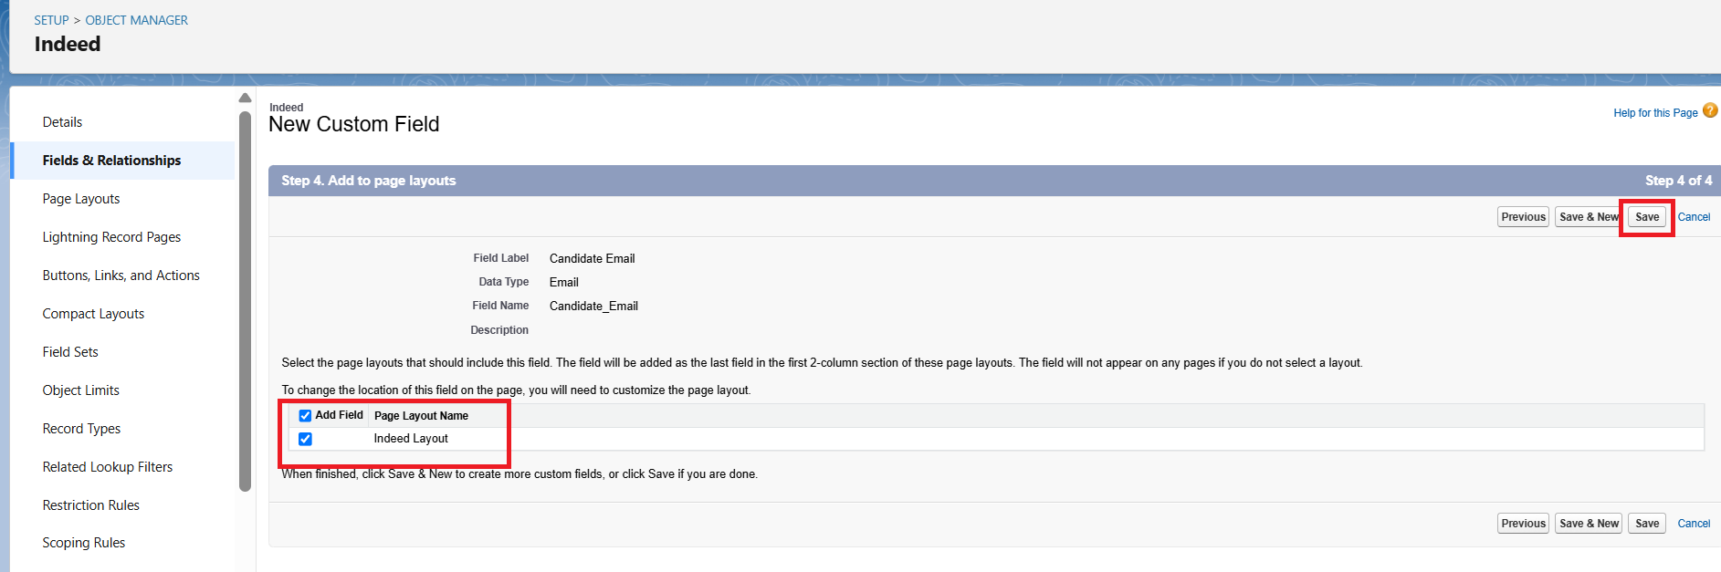

RESULT

Lightning view
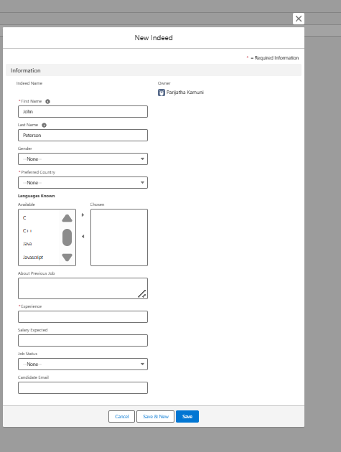

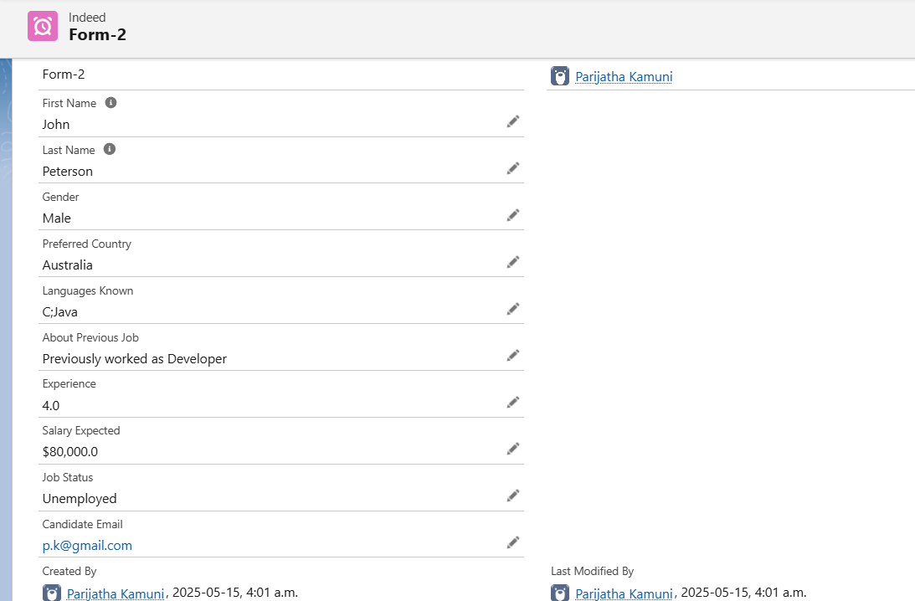

Classic view
